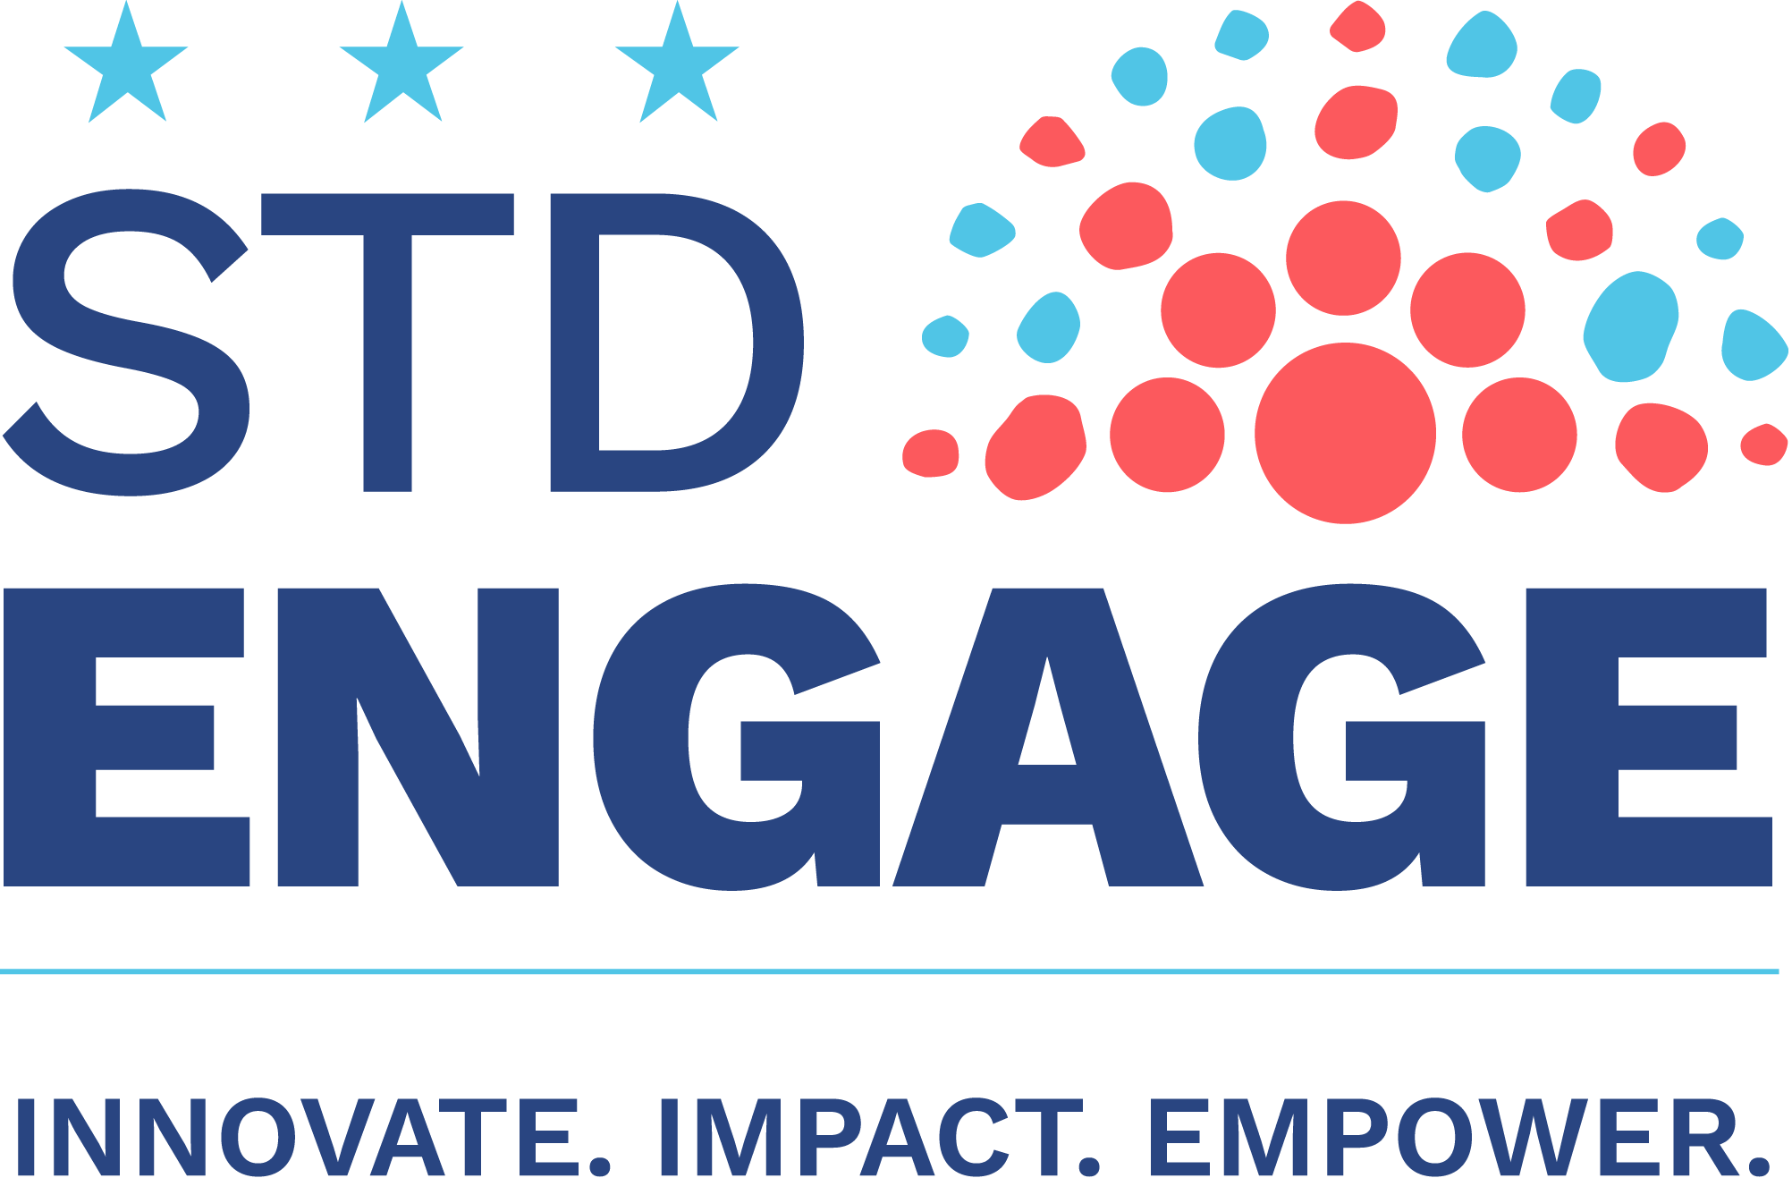

Date

Dear <supervisor’s name>,

I would like to attend the National Coalition of STD Director’s Annual Meeting, STD Engage 2019, on November 19-22, 2019 in Alexandria, VA. NCSD's Annual Meeting is the only national meeting that brings together state and local STD prevention and sexual health professionals, and their community-based partners and allies. Attendance at this meeting will enable me to attend a variety of trainings and educational sessions, and connect with a network of colleagues from health department programs from across the country.

I plan to achieve the following objectives: [Examples – I plan to bring back information from three research studies that affect our work on XXX. I plan to meet with five companies that we could partner with on XXX.]

- [Insert your first objective here.]
- [Insert your second objective here.]
- [Insert your third objective here.]

All of the sessions will provide practical examples that will strengthen [insert program/health department/organization], and relay the tools needed to serve our community in a challenging environment. Each session will provide slides and other learning materials that I can bring back and share with my colleagues in our office.

I understand we have to be very conscientious of where we spend money. Therefore, I have broken down the costs for me to attend this meeting.

- Airfare: <$xxx>
- Ground Transportation: <$xxx>
- Hotel: <$xxx>
- Meals: <$xxx>
- Registration Fee: <$xxx>

The total costs associated with attending STD Engage 2019 are: <$xxx>

Again, I believe that the knowledge and professional contacts that I would gain at STD Engage would be invaluable to our organization and that they will help us strengthen our work.

Thank you for your consideration!

Sincerely,

<your name here>

