June 3, 2021

FUNDING IDEAS CATEGORIZED

BY KEY NOFO ACTIVITIES

Conduct Programmatic and Community Needs Assessment and Gap Analysis

Enumerate Current Staffing and Future Staffing Needs

Support and Expand DIS Workforce (Hiring and Contracting) Including Retention and Supervision
- Hire DIS, reclassify if needed.
- Institute AmeriCorps type funding for new staff, with loan forgiveness
- Investment in DIS supervision
- DIS pay raises
- Better funding for LHDs for DIS
- Hire Epis
- More DIS in regional programs
  - DIS who are RNs to provide treatment and COVID vaccinations in the field
- Hep C DIS
- Revisiting previous patients to connect them with COVID vaccines
- Assign a DIS to the SSPs
- Directly funding tribal nations in jurisdiction
- Leveraging COVID contact tracing infrastructure
- More DIS in central office for quick deployment
- Regional STD prevention coordinators to provide technical assistance and training for DIS
- Embedded DIS and DIS with non-traditional hours

Address Community Resilience Needs (Health Equity, Cultural Competency, Vaccines, tests, Treatment)
- Create a peds unit
- Provide more services to IDU population, potentially bring in social workers to support DIS work

Support DIS Training Education
- Expanding workforce training, especially in health disparities
- Different skills expertise for different DIS

Train, Equip, and Maintain Staff to Respond to Incident Infections and Outbreaks
- HIV specific navigators for LTC, cluster response, and partner services
- Field GC/CT testing that DIS can do
- Public health/provider detailing
- Purchasing telehealth platforms and providing comprehensive trainings on them
- Cross-train or support medical staff and clinicians

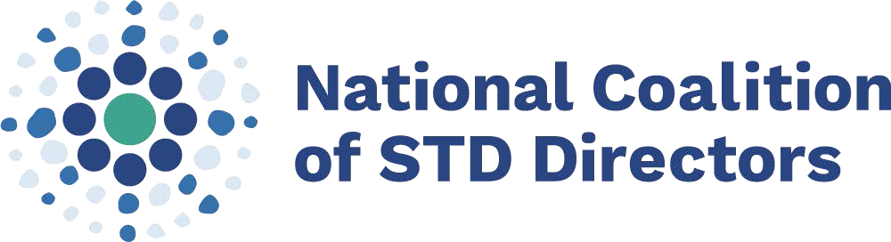
FUNDING IDEAS CATEGORIZED BY
KEY NOFO ACTIVITIES

Focus on Diversity, Health Equity and Inclusion – DIS and Communities Served
- Community based assessment of gay and bi men of color
- PSAs for STIs
- Funding for more comprehensive work by DIS, for example, re-engagement work
- Fund community health centers to incentivize women’s partners to come in for testing
- School-based projects
- DIS task force to address IDU

Case Detection, Treatment, Reporting, Contact Tracing, Linkage to Care Including Surveillance and Data Management
- Self-notification systems
- Opt in partner service systems
- Build out surveillance system and case management system to handle EvaluationWeb reporting
- Syndromic surveillance systems – case-based reasons to connect providers with detailers who
missed patient symptoms, etc.
- Health navigators
- Integrated condition navigators
- Expanding emerging infections work in the lab
- Expand and collaborate with contact tracing unit and services
- Expand field phlebotomy program
- Partner with clinics and put out RFR to pay them for direct or remote access to clinic EMRs
- Create team to investigate multiple infections for risk reduction
- Create warm line to provide clinical consultation and manage patients through telemedicine
- Buy PRISM or other partner service software
- Integrated linkage to care workers to help folks who use access services
- Community assessment of partner services work
- Hire clinical consultant
- Contact tracing paired with home STI kits
- Warm referral for deployment for epi treatment
- Offload data entry through electronic case recording
- Add more surveillance resources to be able to go paperless

Program Evaluation
- Beef up DIS evaluation team (creating supervisor and whole team) to address trends
- Quality assurance and improvement for DIS

Miscellaneous
- Cross-state work
  - Translating expanded COVID technological infrastructure to other diseases, which will greatly expand capacity
- Recreate IPP

About NCSD
National Coalition of STD Directors is a national organization representing health department STD directors, their support staff, and community-based organizations across 50 states, seven large cities, and eight US territories. NCSD advances effective STD prevention programs and services in every community across the country.

